My name is Thurston Foo, currently a fourth-year student, and I have recently completed my internship at the University of Gdańsk in Poland. My experience there has been nothing short of amazing; I made new friends, precious memories, and learnt many new things both academically and outside of it. I had already expected an incredible experience after hearing so many stories from seniors who have had their internships there previously and knowing the fact that I will be abroad in Europe no less, but after coming back I can confidently say that it had completely blown my expectations out of the water. Truly, it was an immensely fulfilling journey from beginning to end.

I worked under the supervision of Dr. Thomas Złosnik (Prof. Tom) in a group with my fellow classmate Yun Ten in exploring and developing some cosmological consequences to an extension of General Relativity, one which was conceived by Prof. Tom and his colleague. They found a set of models of gravitation which includes both Einstein’s theory of General Relativity and some other model, which for some reason we call Model B. This Model B is the focus of our research project. Model B is distinctive in that its gravitational field has no degrees of freedom and has more symmetry than General Relativity. We studied Model B in FRW symmetry, deriving its equations of motions and studying its implications.

Work every day took place in the Institute of Theoretical Physics and Astrophysics, in the ‘PhD Incubator’. What I would do at the office may not sound exciting as it typically just involves reading up on materials provided or suggested Prof. Tom, performing calculations, and deriving equations, but I look forward to it every day. Up to twice a week would we meet up with Prof. Tom to discuss about the research, its content and progress, and have our usual chatters about anything in particular after discussing physics. It was always a joy to natter about with Prof. Tom, be it about physics or day-to-day life; he is a fantastic mentor endowed with a wealth of knowledge which he generously shares with us. I could not be more grateful for his guidance throughout my internship. Aside from a great supervisor, the faculty members and other students are also all so amicable and down to earth; I have only met wonderful people in the physics faculty there.
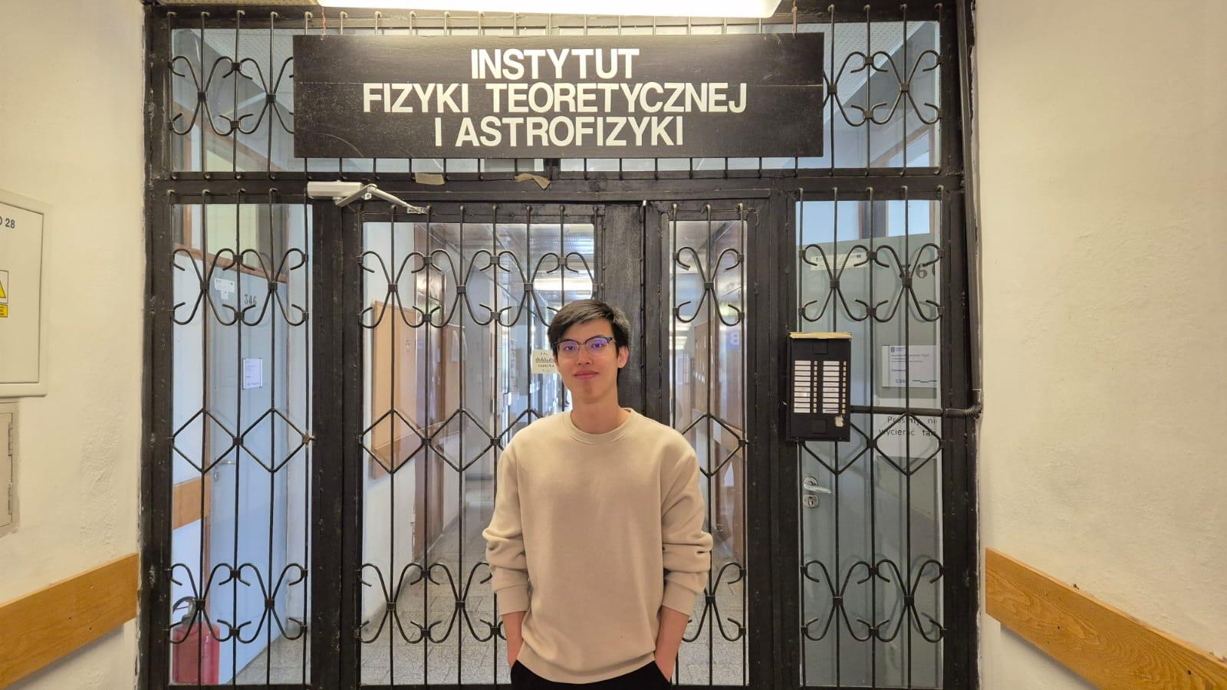
At the entrance to the Institute of Theoretical Physics and Astrophysics

Besides working on the research project, I also made the effort to thoroughly enjoy myself there. My stay in Poland had been a treat. I arrived in Gdańsk just after winter had waned and I had the opportunity to relish springtime there; watching the flowers bloom had been a feast for my eyes. Never had I witnessed barren trees slowly turn thick and green, and empty plains suddenly burst and pop brightly with budding flowers. The weather was great (really cold, but I enjoyed it) and I took delight in walking around the city and at parks which are scattered all around. I also travelled to numerous places around Poland, each laden with rich history, each enthralling with breathtaking beauty, each having charms unique to itself. Three places which I am absolutely fond of are Słowiński National Park, Wrocław, and Kraków. While I definitely enjoyed the many other places I travelled to, these three left a powerful, lasting impression on me, and I feel so fortunate to have visited them.
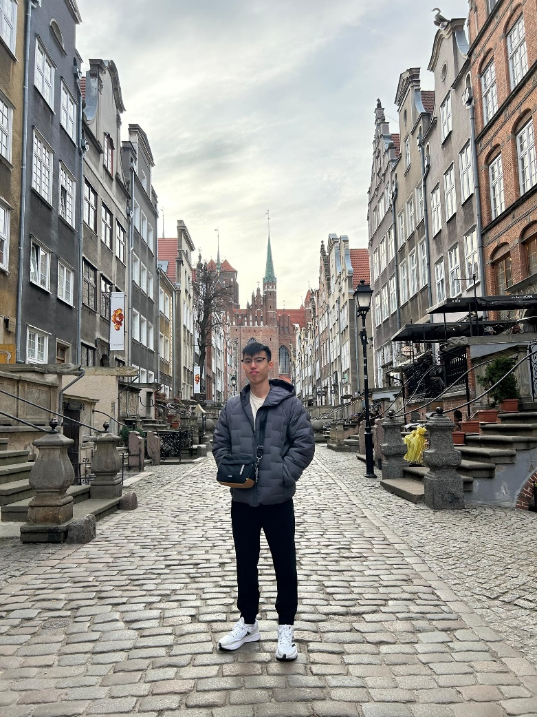
Along a street in the old town of Gdańsk

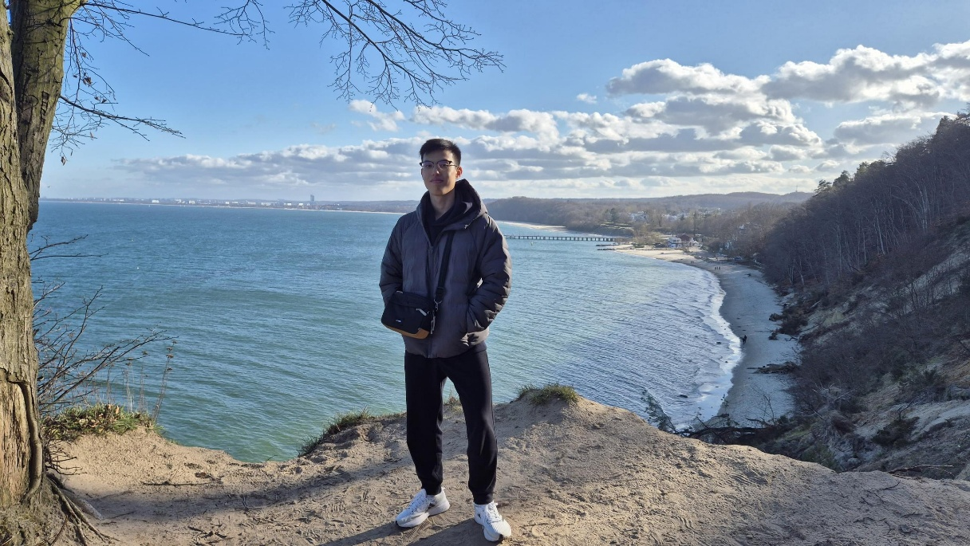
On a cliff by the ocean in Gdynia

Without a doubt, this internship in Poland is, and will be, the biggest highlight of my university life as an undergraduate. I truly am so grateful for this opportunity and for the support I have been given that allowed me to realise it. Now that I am back in Malaysia, I already long to return to Poland - to visit the amazing people I have met, to revisit the enchanting places I have been, and to make new, cherished memories there.

